METAZACHLOR and QUINMERAC: BASF’s Water Stewardship Programme

How to view Surface Water Drinking Water Safeguard Zones (SWDWSgZ) using
on the Environment Agency’s “Check Zones” website: -

Google: EA check zones

Select:

Click:

Enter: Postcode/place name (top of left of screen)

Click: Search, or press return on your keyboard

Select: Drawing tool from ‘Information Summary’
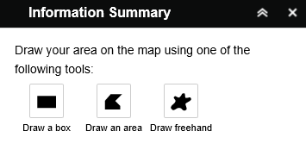

Click: On box drawing option. Draw on map around area of interest

Click: On zone highlighted yellow for information on reasons for concern

