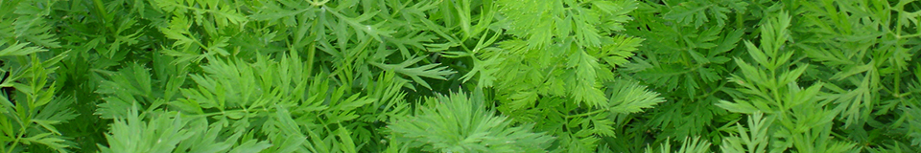
Carrot sclerotinia monitoring
11 July 2018

Key points
- Dry soils at the carrot monitor sites and no germination of sclerotia in the grids yet.
- Dry conditions mean that sclerotinia sclerotia are unlikely to germinate, and airborne spore inoculum levels are expected to be low. However, if irrigation is applied, this could stimulate sclerotial germination.
- Infection risk to young carrot crops is currently low as there is no senescent foliage and the indications are that airborne spore inoculum levels are low.

Actions
- Monitor ground cover progress of carrots. No sclerotinia fungicides are required at this stage, but may need to be considered as the crops approach canopy closure.
Overview

This is the fourth report in 2018 for sclerotinia monitoring at two carrot crop sites, near Mansfield in Nottinghamshire and near Bury St Edmunds, Suffolk. The dry weather continues and sclerotia of the pathogen Sclerotinia sclerotiorum are unlikely to germinate in the dry soil surfaces. Where there is soil moisture, sclerotial germination wold be expected to occur by now, in carrot crops and also in winter cereals and other arable crops. Soils would need to remain moist for at least a few consecutive days for germination to start. We are monitoring the buried sclerotia for germination onset and progress (see chart below). For carrot crops at early stage with low ground cover and no decaying foliage, the current risk of sclerotinia infection is low.

Weather conditions
As in previous weeks, last week was again dry and hot across all areas. Mean rainfall last week was less than 0.5 mm, compared to the long term average of 16mm for that week. The mean air temperature last week was 19ºC, last week compared to the usual 15˚C, but individual areas were warmer, e.g. west and east midlands and eastern areas were 20ºC on average. The Suffolk site reached a high of 28ºC. Soil moisture deficits continue to increase across the country.
Over the weekend the weather is most likely warm but with possible patchy rainfall. In the first half of next week high pressure is likely to shift further away from the UK, and rain showers, some heavy, are expected in some places. But south and eastern areas are forecast to be the driest and warmest.

NOTTINGHAMSHIRE SITE  var Nairobi, drilled 25 May 2018 | SUFFOLK SITE  var Nairobi, drilled 3 June 2017
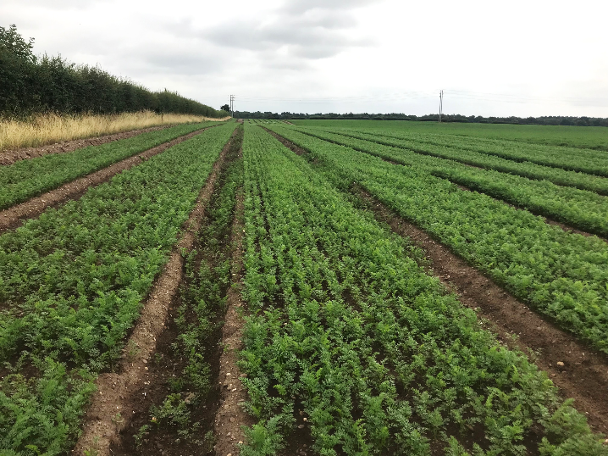 | 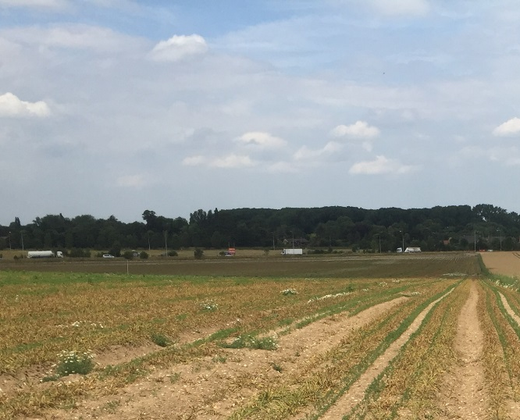
9 July, Notts carrots at 6 leaf stage. Barley ground cover crop now dead. | 10 July, Suffolk carrots 2-3 leaf. Barley ground cover crop senescing.
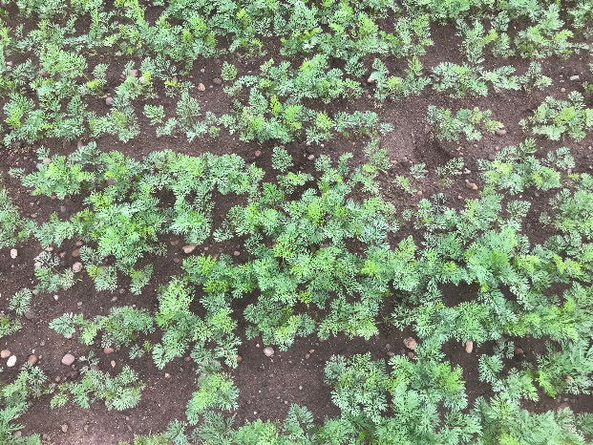 | 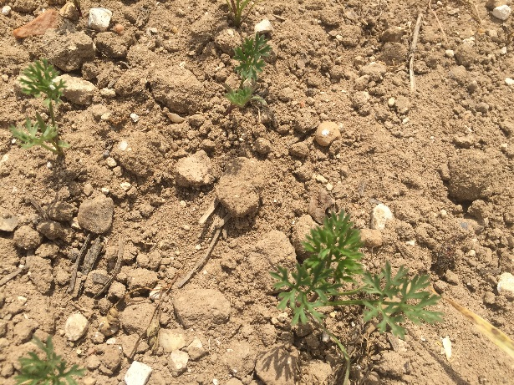
9 July, close up of 6 leaf stage.  Ground cover 20-30% | 10 July, close up of 2-3 leaf stage. Ground cover <5%.
Comments  The crop has received irrigation again this week, but the soil surface has not stayed moist enough to encourage the development of sclerotinia apothecia in the monitor grids, in the carrot crop or the nearby wheat. The weather continues to be very hot and dry. Crops continue to be irrigated, and carrot ground cover is increasing rapidly with plants at 6 leaf stage, compared to 4 leaves one week ago. | Comments  Hot weather again last week with temperatures of 25-28_{o}C, and no rain. The soil is very dry and there is no sign of apothecia. The wheat has senesced and is likely to be harvested within the next couple of weeks. Some of the carrots are still only just coming through, but the cover crop is now senescing
Sclerotia Germination (refer to website map for exact locations)

Depots of carrot sclerotia are being monitored near Mansfield, Nottinghamshire (sclerotia buried 25 May in carrot crop and in nearby wheat crop) and Bury-St-Edmunds, Suffolk (sclerotia buried 12 June in carrot crop and in nearby wheat crop).

