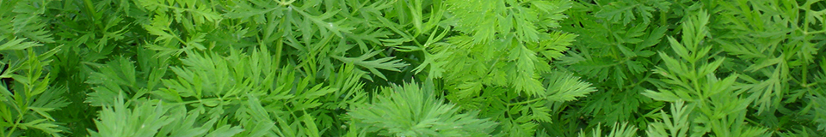
Carrot sclerotinia monitoring
18July 2018

Key points
- Continuing dry soils at the carrot monitor sites and no germination of sclerotia yet. Dry conditions mean that sclerotinia sclerotia are unlikely to germinate.
- Nottinghamshire is near to canopy closure.
- Infection risk to carrot crops is currently low with indications that airborne inoculum levels are low.

Actions
- Monitor ground cover progress of carrots.
- Where carrots are near to canopy closure, check foliage especially at the base of plants, as physical damage or senescence is a route for sclerotinia infection. Protectant sprays may need to be considered if there is rainfall.
Overview

This is the fifth report in 2018 for sclerotinia monitoring at two carrot crop sites, near Mansfield in Nottinghamshire and near Bury St Edmunds, Suffolk. Not surprisingly, continued dry conditions mean that sclerotinia sclerotia in the monitoring grids at shallow depth have not yet germinated. Soils would need to remain moist for several consecutive days for germination to start. It is possible that irrigation can encourage germination, but most likely, irrigation won’t result in a long enough duration of moisture at the soil surface. We are monitoring buried sclerotia for germination onset and progress (see chart below). For carrot crops at early stage with low ground cover and no decaying foliage, the current risk of sclerotinia infection is low. Where carrots are near to canopy closure, check foliage especially at the base of plants for senescent or physical damage. If there happen to be any heavy localised rain downpours, this can be a cause of physical damage to plants.

Weather conditions
Dry conditions predominate in many areas but last week there were some heavy downpours across part of the south of England, as well as in the north. The eastern region however recorded no rainfall at all. Despite some rain, soil moisture deficits were high, approaching 140mm in the South East, especially on lighter land. Temperatures were high, averaging 18ºC compared to a long term mean of nearer 15ºC. But at the Suffolk site, temperatures were again much higher, 28ºC again this week.
The week ahead is forecast to be dry and sunny, with sustained high temperatures. Rainfall is likely in the North and West, but the East and South East are expected to remain mostly dry.
NOTTINGHAMSHIRE SITE  var Nairobi, drilled 25 May 2018 | SUFFOLK SITE  var Nairobi, drilled 3 June 2017
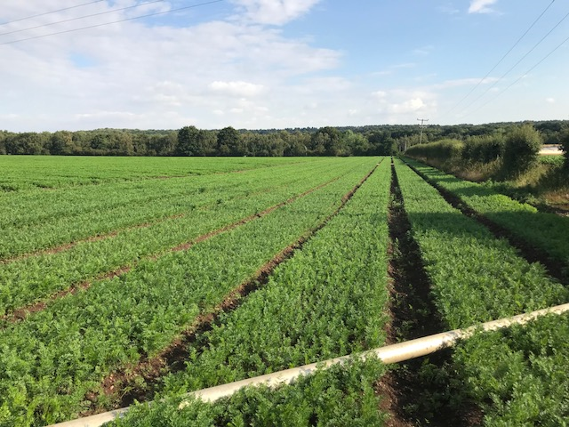 | 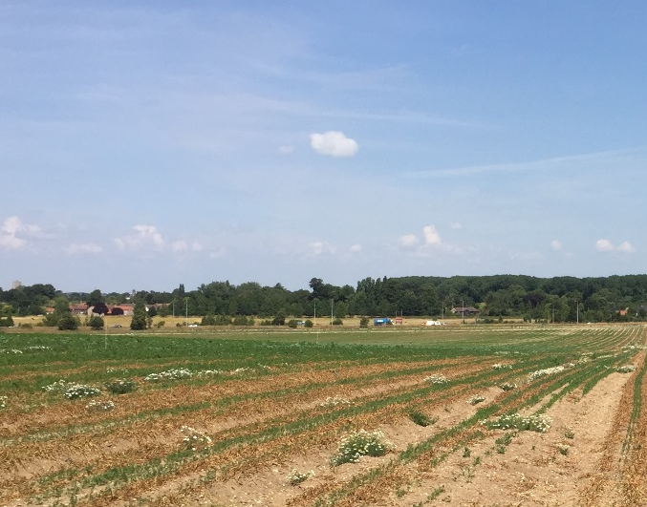
16 July, Notts carrots at 8 leaf stage. | 16 July, Suffolk carrots 3-4 leaf.
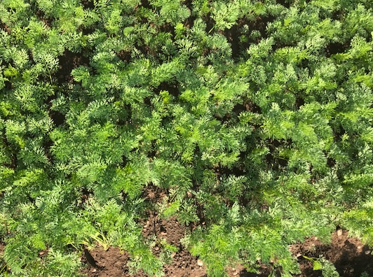 | 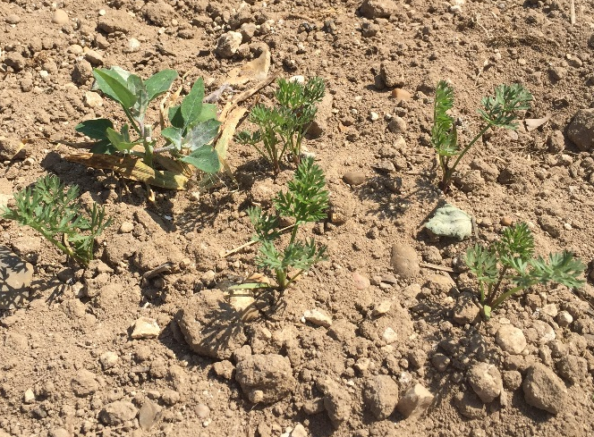
16 July, close up of 8 leaf stage.  Ground cover 80% | 16 July, close up of 3-4 leaf stage. Ground cover still low: 5-10%
Comments  The weather continues hot and dry, and crops continue to be irrigated. Despite overall dry conditions, the Nottinghamshire crops ground cover has increased rapidly with plants at 8 leaf stage this week, compared with 6 leaves last week.  Any rainfall is likely to increase the risk of infection with crop near 100% ground cover. | Comments  Same as last week: hot weather with temperatures of 28ºC, sunny, no wind, and no rain. No sign of Sclerotinia apothecia. Carrot plant development is at 3-4 leaf stage, and delayed compared to the Nottinghamshire crop. Crops were drilled just over a week apart but % ground cover progress at Suffolk site is slower.
Sclerotia Germination (refer to website map for exact locations)

Depots of carrot sclerotia are being monitored near Mansfield, Nottinghamshire (sclerotia buried 25 May in carrot crop and in nearby wheat crop) and Bury-St-Edmunds, Suffolk (sclerotia buried 12 June in carrot crop and in nearby wheat crop).

