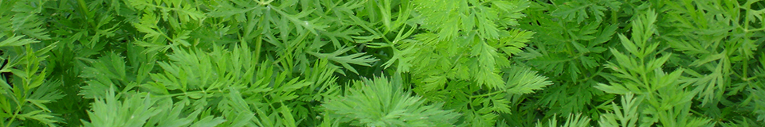
Carrot sclerotinia monitoring
2 August 2018

Key points
- Last week saw the first significant rain in some areas since this year’s carrot monitoring began. No germination yet of sclerotia in the monitor grids.
- Crops should be checked for senescent leaves and any infection. Nottinghamshire monitor crop is now at canopy closure.

Actions
- Monitor carrot foliage. Physical damage or senescence is a route for sclerotinia infection.
- Protectant fungicides may need to be considered - sprays applied just before canopy closure give the most effective control.
- If there is further rain, additional fungicide treatments at 2-3 week intervals should be planned; ensure that products with different modes of action are used.
Overview

This is the seventh report and there has been some rain in the past week, but not enough to stimulate germination of sclerotia at the two monitor sites. We are monitoring buried sclerotia for germination onset and progress (see chart below: zero activity). The Nottinghamshire carrot crop is at full canopy closure, and foliage at the base of plants will need to be checked for senescence and/or damage, which will encourage infection. Physical damage can result from localised rain downpours, which are a possibility with the current weather situation. The crop at both monitor sites is var. Nairobi, which is noted for its relatively heavy and dense foliage, which has a tendency to flop onto soil and will create ideal infection conditions, especially for sclerotinia. The risk of sclerotinia infection is higher in shorter rotations and if the disease has been seen in previous years on the farm, including in other susceptible crops besides carrots (e.g. peas, potatoes, oilseed rape).

Weather conditions
The weather broke last week with a band of storms across the country. The mean weekly GB rainfall was 28mm for the week ending 30 July; more than twice the normal amount. However, the West Midlands remained notably drier than other areas, averaging 14mm. Despite rain, temperatures remained high last week, 19ºC average (4˚C above the long-term average). This coming weekend is forecast to be dry, sunny and warm/hot. Next week is predicted to be a little cooler mid-week, with some rain predicted from the NW but which is unlikely to reach the midlands or south areas.
NOTTINGHAMSHIRE SITE  var Nairobi, drilled 25 May 2018 | SUFFOLK SITE  var Nairobi, drilled 3 June 2017
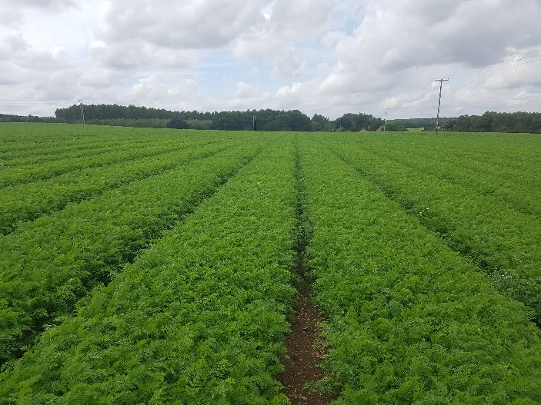 | 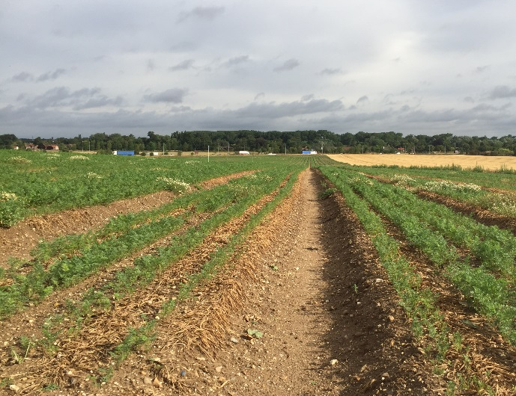
30 July, Notts carrots canopy closure | 30 July, Suffolk carrots at 6 leaf stage.
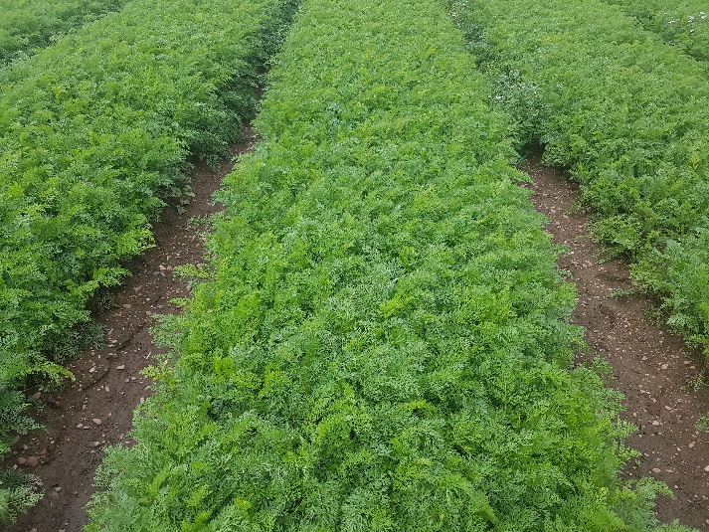 | 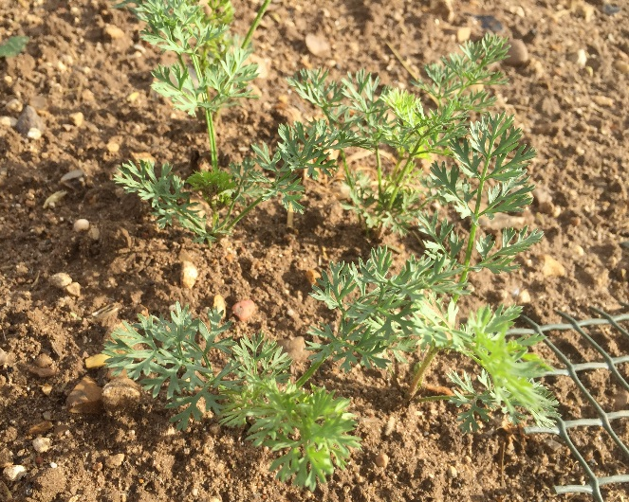
30 July, close up of, Ground cover 100% | 30 July, close up of 6 leaf stage. Ground cover 20-30%
Comments  No apothecia in the carrot crop, despite a full crop canopy and weekly irrigation. The soil has most likely been damp only for short periods of time, and there have been few overnight dews. Temperatures were up to 33ºC last week, but the previous weekend 21 July had 15-20 mm of rain recorded.  Carrot crops in the area that have been irrigated regularly look very healthy: no signs of foliar disease and very few aphids in crops. Fungicide applications to prevent canopy infection are underway in main crops now, with trace elements being added as required. | Comments  Change of weather this week: temperatures down to 20ºC compared with 30ºC last week, and enough rainfall to result in patches of soil holding moisture, but still some dry patches now appeared. No Sclerotinia apothecia have appeared yet. Carrot plant growth progress is looking better with the rain and plants are now at about 6 leaves.
Sclerotia Germination (refer to website map for exact locations)

Depots of carrot sclerotia are being monitored near Mansfield, Nottinghamshire (sclerotia buried 25 May in carrot crop and in nearby wheat crop) and Bury-St-Edmunds, Suffolk (sclerotia buried 12 June in carrot crop and in nearby wheat crop).

